SANDCASTLE, POINT PIPER

Krause Emperor bricks make their mark on a beautiful home

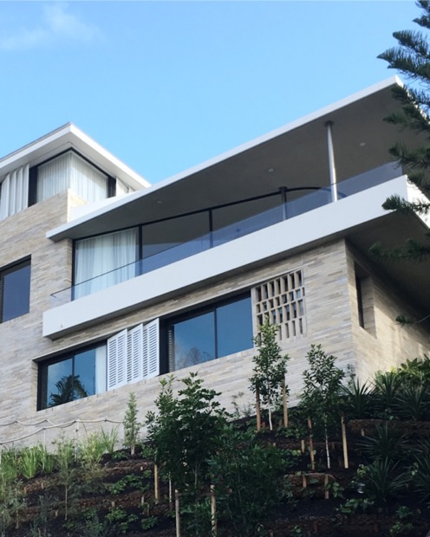
Set high above the street in Point Piper, Sandcastle’s magnificent design by the team at Luigi Rosselli Architects, in collaboration with Raffaello Rosselli Architects, delivers on the brief to capture breathtaking views, maintain privacy and design a robust and low maintenance, yet stunning home.

Krause bricks are the standout material in the simple, natural palette. They provide a warm contrast to the crisp, white render on the external facade and combine well with the natural American Oak finishes inside.

Luigi Rosselli (Luigi Rosselli Architects) and Raffaello RossellIi (Raffaello Rosselli Architects) are the creative brains behind this design; an absolute standout in terms of detail and finishes. Despite an initial reluctance by their clients to select brick, Raffaello was determined to show his clients the true value of bricks and stand by his passion–applying sustainable building practices using carbon neutral materials.

“The Krause Emperor Ghost brick is a beautiful brick, and not something that you’d usually see, because there seems to be some reluctance by clients to use bricks for high end jobs. So, we wanted to show them that bricks can be beautiful, and are not just reserved for project homes. In doing so we hope to remove some of the stigma in the street and provide something different,” Raffaello comments.

In fact, the Krause Emperor bricks have created quite the impression on both owners and passers-by, their light, sandstone tones evoking a sense of elegance and warmth to this four-bedroom, four-bathroom home.

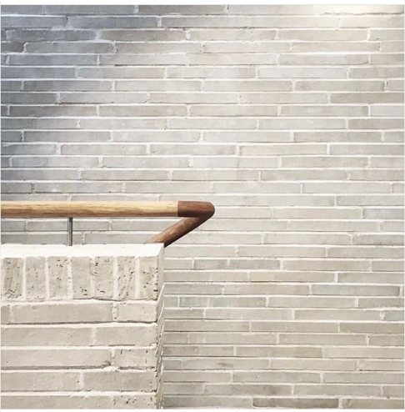
Externally, the slimline bricks have been used in an offset pattern, breaking up the façade and adding beautiful detail. Most striking is the stunning brise soleil. Adding an interesting depth to the facade, and placed on an angle, it captures filtered light to create a sense of privacy for the owners while maintaining access to water views.

Inside, the bricks have been applied in a more muted form, courtesy of a limewash, with brilliant results. “The vibrance of the bricks is beautiful and bringing them inside looks great … On the outside of the house, bricks provide a big contrast, but we wanted the inside feeling to be relaxed, so more muted, and less visible in the palette, and the limewash really helped to achieve that,” Raffaello reflects.

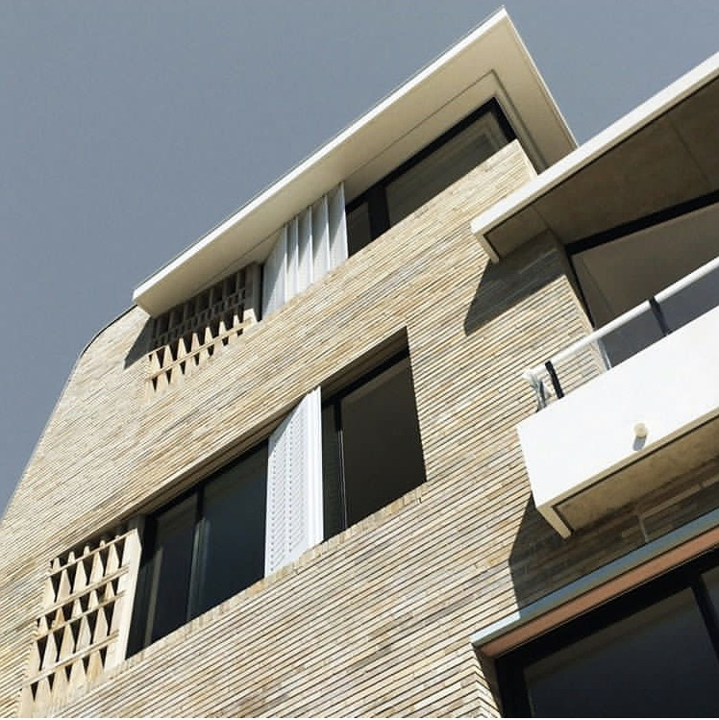

Best of all, the owners couldn’t be happier. “They have now moved in and are really happy, and they really love the bricks, especially inside. Actually, they are one of the things they love most in the end, and I really love them too,” Raffaello says.

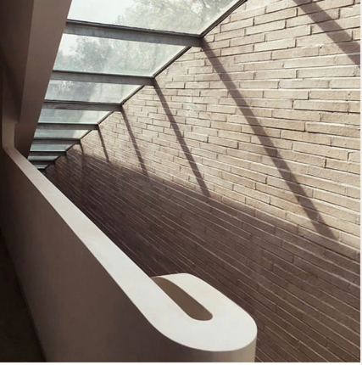
Project: Luigi Rosselli Architects
Design Architects: Raffaello Rosselli Architects
Project Architects: Raffaello Rosselli Architects,
Jeffrey Blewett
Product: Krause Emperor bricks, Custom Blend
Builder: Cumberland Build
Photographer: Jeffrey Blewett

